Certificate of Registration
Spectrum Batteries, Inc.
6910 Sprigg Street, Fulshear, TX 77441
have been assessed and approved to:
ISO 9001:2015
Quality Management System
The approved management system applies to the following scope:
Spectrum Batteries, Inc. is engaged in the design, development, fabrication, supply and repair of battery packs/modules, principally for oil field applications.
Original Approval 8th June 2007
Current Certificate 8t^{h} June 2023
Certificate Expiry 8th June 2024
Certificate Number US2491

Signed: Certification Officer | 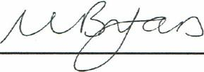

This certificate remains valid while the holder maintains their administration systems in accordance with the standards and guidelines stated above, which will be audited annually by CtAS International. The holder is entitled to display the above registration mark for the duration of this certificate, which should be returned to QS International upon reasonable request.
Issuing Office: CAS International, 5 Technology Park, Colindeep Lane, London, NW9 68X, UK Tel: 020 31989788 • info@qas-intemationaLcom • https://wwwqas-intemational.com

